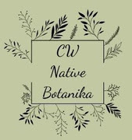  Herbal Infused Skincare  Neem Oil Soap is fabulous for your skin and repels biting bugs in the summer!  Neem oil is often used on plants to repel insects, but it is much too valuable to use on plants.  When used on plants this important oil is discarded and harms insects and pollinators indiscriminately. |  | https://www.cwnativebotanicals.com/  cwnativebotanicals@gmail.com  CW Native Botanika 12288 Tonawanda Creek Road Akron, NY 14001 (716)417-2626 |  |  |  | CW Native Botanika  - An Apothecary Skincare Company  - Neem Oil Soap  Research has found some soaps attract biting insects. While some commercial soaps attract insects – neem oil soap repels insects including biting flies, mosquitos, bedbugs and ticks.
Ayurveda medicinal practices have turned to the Neem oil tree for thousands of years.  The neem tree is called “Indian Lilac” tree or “margosa tree” considered to have many restorative properties.  Neem oil is a wonderful carrier oil. The Neem tree is native to India and incorporated into the culture so much so that they call it the “village pharmacy.”    Azadirachta indica is a sacred tree in India and in Ayurveda. The oil comes from the seed and is a rich, dark brown color. It can solidify in cooler temperatures and smells like funky garlic. |  |  | Neem oil chemical properties include Oleic Acid, Palmitic Acid, Stearic Acid, Linoleic Acid, Vitamin C, and Carotenoids. These properties are why neem oil is so medicinal 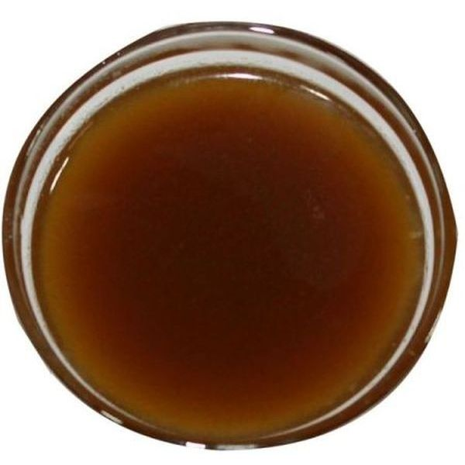  Used Topically or in Soap Neem oil Imparts powerful healing.  Neem oil will soothe inflamed skin so is perfect for acne, burns, eczema, and psoriasis. An important benefit to using neem oil is that it protects skin from damage due to UV rays. It restores moisture, enhances elasticity, and stimulates collagen production.  On my own skin neem oil has helped heal keloids scars and other skin imperfections. |  |  | Neem Oil is in Every Bar of Soap We make!  Fabulous Products  --Satisfied Customer  “Amazing!!! I’m a farmer that works in wood-surrounded areas and with horses that attract biting flies. I was skeptical of natural soap at first, but this turned me into a straight up insect ninja – I was invisible to biting insects”  --Satisfied Customer  Our Neem oil soap comes in Many forms.  - Unscented, Goat’s milk, Vegan and Raw honey neem oil soap  - Even our bug off cream has a touch of neem oil in it.  Still skeptical – ask me for a Sample!

